UTut: University Tutor
Project Terminal Report

Submitted to:

Prof. Ma. Rowena C. Solamo
Faculty Member
Department of Computer Science
College of Engineering
University of the Philippines, Diliman

Submitted by:
De Guzman, Jade
Mendoza, John Dominic
Segismundo, Julio Ismael

In partial fulfillment of Academic Requirements
for the course
CS 192 Software Engineering II
of the
2nd Semester, AY 2017-2018

Unique Reference:
The documents are stored in the https://github.com/Midokuni/UTut.
https://github.com/Midokuni/UTut/blob/master/CS192%20Documents/Beta%20testing/Beta-testing%20Report.odt

Document Purpose:
Analysis of the Beta Testing results

Target Audience:
People who are interested in looking at the results of the beta test

Revision Control:
Revision Date | Person Responsible | Version  Number | Modification
05/22/18 | JD Mendoza | 1.0 | Initial Document
05/22/18 | Jules Segismundo | 1.1 | Sections IV onward
05/23/18 | Jade De Guzman | 1.2 | Sections VI onward and some other changes

Table of Contents
I. Project Description 4
II. Scope and Limitation of the Project 4
III. Issues and Challenges 4
IV. Software Architecture 4
V. Results of Beta-testing 5
A. Testing Environment 6
A.1. Hardware Specifications 6
A.2. Software Specifications 6
B. Demographics 6
C. Analysis of Functional Testing 7
D. Analysis of Usability Testing 10
E. Recommendations for the Next Software Release 11
VI. Lessons Learned from the Project 12
VII. Summary 13
Appendix A: Accountability Report 14
Appendix B: Beta-testing Checklist 15
Appendix C: Final Agile Estimates 17
Appendix D: Installation and Configuration of Beta-tested Software 18
Appendix E: Team Performance Assessment 19

I. Project Description
UTut is a web application that addresses the problem of UP students looking for fellow students who are willing to tutor them on certain courses. The goal of this project is to create an application that makes it easier for students to find a tutor for a course.

II. Scope and Limitation of the Project
At the moment, the application is limited to students of UP since the user IDs are based on the UP Student ID Numbers. Everything that has been deemed a “Must Have” from the Requirements Traceability Matrix has been implemented.

III. Issues and Challenges
The biggest problem that happened is the start where we do not know how to use Ruby on Rails and are trying to figure out how it works. There is also the issue of not being able to meet-up with the whole team, there is always at least one of us that isn’t able to be present.

IV. Software Architecture
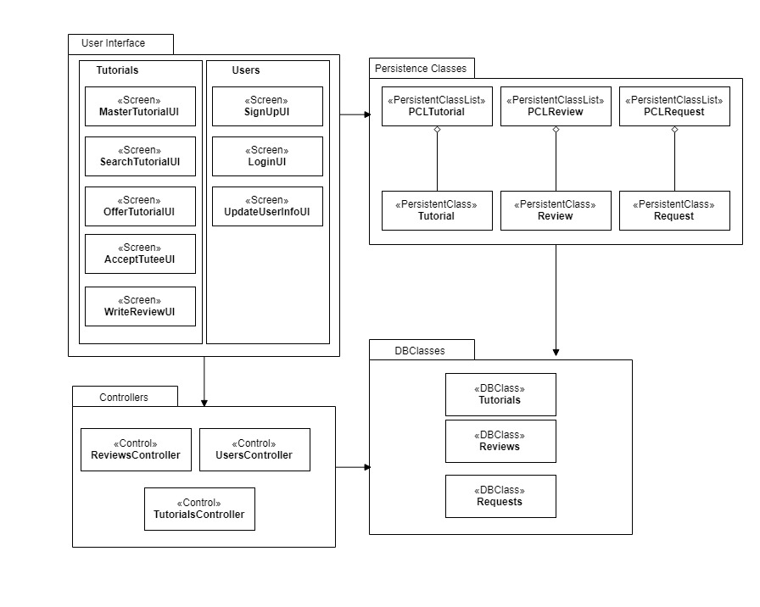
1. Illustration: UTut Software Architecture
User Interface
- MasterTutorialUI – Contains the links to all tutorial related actions (offer, search, accept).
- SearchTutorialUI – Allows the user to search for a tutorial based on subject name and schedule parameters. The user can request a tutorial on any tutor that appears in the search results.
- OfferTutorialUI – Allows the user to post a tutorial on the specified subject and schedule.
- AcceptTuteeUI – Allows the user to accept or reject a tutee’s request on a tutorial.
- WriteReviewUI – Allows the user to write a review on their tutor after the tutorial is done. The review includes the rating and subject.
- SignUpUI – Allows users to sign up.
- LoginUI – Allows users to log in.
- UpdateUserInfoUI – Allows users to update user info such as description and password.
Business Logic Classes
- ReviewsController – Handles operations on user reviews such as adding user reviews.
- UsersController – Handles operations on user accounts. These include sign up, log in, and updating info.
- TutorialsController – Handles operations on tutorials. These include searching, offering, accepting/rejecting, requesting
Data Design Classes
- DBTutorials – Contains tutorials table.
- DBReviews – Contains reviews table.
- DBRequest – Contains requests table.
- PCTutorial – An instance of a record in the tutorials table.
- PCReview – An instance of a record in the reviews table.
- PCRequest – An instance of a record in the requests table.
- PCLTutorial – A list of tutorials from the tutorials table that satisfy the search parameters.
- PCLReview – A list of a user’s reviews on their profile.
- PCLRequest – A list of tutorial requests on all the user’s offered tutorials.
Beta-tested software release: https://github.com/Midokuni/UTut/releases/tag/Beta
Software demonstration video link: https://youtu.be/UxmhuxcqAVU

V. Results of Beta-testing
For the beta-testing, we asked from 30 students of the University of the Philippines to test our software and the following are the results of it.

A. Testing Environment
A computer that runs the UTut software is set up. Two windows are opened in the browser. One instancec of the browser is opened normally. The other is opened in private browsing mode to allow for another user session. The browser in private mode (window 2) will be signed in to a premade user account that already has a tutorial offered. This is so that the user in window 1 can search for a tutor, request a tutorial from the user in window 2, and use window 2 to accept their own request.

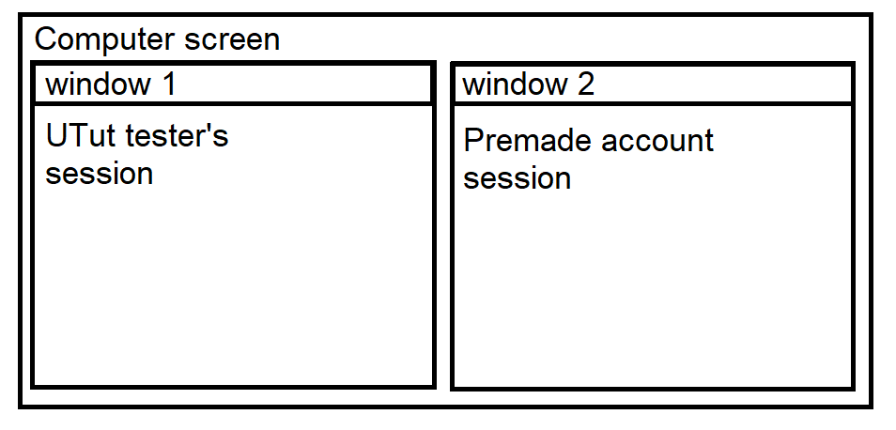
2. Illustration: Testing Environment

A.1. Hardware Specifications
The server is currently run locally. It can be deployed into the cloud. UTut is a web application, which means it can be opened through any browser. It is recommended that the client is on desktop since UTut does not have mobile support yet.

A.2. Software Specifications
UTut can be run on any OS. It users SQLite3. Any browser can access UTut. There is currently no web server.

B. Demographics
The beta testers were Computer Science students in UP Diliman who are not taking CS 192 this year.

C. Analysis of Functional Testing
All features in functional testing have been marked as “Yes” which signifies that all features are working properly.
Tester comments:
“Password is too short” error should say minimum characters required.
Clarify the subject format when offering a tutorial.
There should be a “master list” of all tutorials and filter from there.
Routing error on tutor side when accepting a tutee.
Cookie overflow when there are too many tutorials to be displayed on search.
Consider direct tutor search (searching for a name).
Some features are buggy / shows server-side errors.

D. Analysis of Usability Testing

The average SUS score during the beta test was 81.4167.

E. Recommendations for the Next Software Release

For the next software release, most of the comments are regarding the UI/UX of the system since the beackend of it is much simpler compared to other softwares.
The colors of the application and the name of the application can be improved to make it look more like a professional website since the use of it is very professional work and it involves some kind of job for the students.
The review function of the application is still faulty at this moment. There are so much things that can be done here like adding a review once or include the name of the reviewer for the authenticity of the review.
The profile page can be more improved with profile pictures and more descriptions needed like how LinkedIn did it since this is also a “job finding” application.
The overall feel of the application is still on the improving side. Since the team only started learning development this semester, these are just the minimum version of the system. If more experienced people have the time to look into it, and improve on it, we, the developers of UTut, is willing to give our opinions and insights about the project.

VI. Lessons Learned from the Project

This part of the project documentation will be sectioned into two parts, us being software engineering when it comes to the technical side, and us being software engineers when it comes to our team collaboration.
For the technical side, we used one of the easiest frameworks for beginners, Ruby for Rails, that’s why it was easier for us to adjust to the system. By being able to do all of the required functionalities, we were able to move around the framework with ease. JD and Jules worked on most of the backend and database stuff while Jade worked on the UI/UX of the application.
UTut is a simple system with a good cause for the University so it was a great time doing it for us doing it since there’s a vision for us to continue doing it.
Our performance as a team, according to the things that we were able to deliver is great since there are no left-behinds but when it comes to how the team did it, we have a lot to improve on. Physical meetings should be done more often to be able to know the status of the project. Every sprint, we try to do this but since we are students, we have other things to work on like organizations and other courses. Also for our situation, when we develop the application, we were in different places and different machines. These meetings can also help with equal distribution of work. But there were also a lot of time when we actually help each other out since our workloads were different. Good communication is key to a good team and good product.
We also have a platform that we used to communicate was Discord and it was of great use for us because there is a github integration to the platform so we were able to see our progress via the commits of the members.
All in all, with this team, our deliverables were always done but it would’ve been better with open communication.

VII. Summary

Appendix A: Accountability Report

Beta-Testing Tasks | Accountability
Prepared software for alpha- testing. | JD Mendoza
Prepared software for alpha- testing. | Jules Segismundo
Prepared testing environment | JD Mendoza
Created the Alpha Software Release in github | Jules Segismundo
Created and replicated Alpha-testing Checklist | Jules Segismundo
Facilitated alpha-testing | JD Mendoza
Facilitated alpha-testing | Jules Segismundo
Synthesized and documented the results of the alpha-testing | Jules Segismundo
Prepare software for beta-testing | Jade De Guzman
Prepare software for beta-testing | Jules Segismundo
Prepared testing environment | Jade De Guzman
Prepared testing environment | Jules Segismundo
Created the Beta Software Release in github | Jules Segismundo
Facilitated beta-testing | Jade De Guzman
Facilitated beta-testing | Jules Segismundo
Synthesized and documented the results of beta-testing
Created the video | Jade De Guzman
Submitted the document

Appendix B: Beta-testing Checklist

Beta Testing Checklist

Project Name |  | Project ID  (if applicable)
Beta-testing Date

This checklist is to be used to assess if beta testing goals have been achieved. There are two categories of goals. One is the functional goals and the other is the usability goals. Functional goals are the target features of the software that should have been built during the semester. They are based on user acceptance criteria identified. Usability goals are used to test how usable the user interface of the application is.

Target Audience: UP Students or others

Tester Information:
Tester's Name: | Year Level | Gender

Instructions: Place a check mark (√) if the software complies with the criteria. Place a cross mark (X) if it does not, and place a comment on its non-compliance.

Functional Goals:
User Acceptance Criteria | Compliance |  | Remarks
User Acceptance Criteria | Yes | No | Remarks
Create User Account
Update Account Information
View Account Information
Sign in and sign out
Offer Tutorial (as Tutor)
Search for Tutorial (as Tutee)
Request Tutor (as Tutee)
Accept/Reject Tutee (as Tutor)
Write Review (as Tutee)
Total

Tester's Comments:

Usability Goals:
This is the System Usability Scale (SUS) used to measure users' perceived usability of a product or system. It is highly reliable (0.91). Mark the most appropriate box that shows how much you agree with the statement.

System Usability Scale Standard Version | Strongly Strongly Disagree Agree
System Usability Scale Standard Version | 1 | 2 | 3 | 4 | 5
1. I think that I would like to use this system.
2. I found the system unnecessarily complex.
3. I thought the system was easy to use.
4. I think that I would need the support of a technical person to be able to use this system
5. I found the various functions in the system were well integrated.
6. I thought where was too much inconsistency in this system.
7. I would image that most people would learn to use this system very quickly.
8. I found the system very cumbersome to use.
9. I felt very confident using the system.
10. I needed to learn a lot of things before I could get going with this system.

Computation of SUS Score:
For odd items: subtract one from the user response.
- For odd items: subtract one from the user response.
- For even items: subtract the user response from 5.
- This scales all values from 0-4 (with 4 being the most positive response).
- Add up the converted responses for each user and multiply that total to 2.5. This converts the range of possible values from 0 to 100 instead of from 0-40.

SUS Score: _________________

Tester's Comments:

Appendix C: Final Agile Estimates

Appendix D: Installation and Configuration of Beta-tested Software
UTut requires Ruby version 2.25 and Rails 5.1.4.

- Upon pulling the code in the beta release (https://github.com/Midokuni/UTut/releases/tag/Beta), open the command window.
- Move to the directory containing the UTut source code.
- Enter the command ‘bundle install’ without the quotes.
- Enter ‘rails db:migrate’ without the quotes to initialize the database.
- Enter ‘rails server’ to run the server locally.
- Open any browser and go to localhost:3000 to access UTut.

Appendix E: Team Performance Assessment

http://chaione.com/ux-research-standardizing-usability-questionnaires/

